

STEM Camp is not just in July! During the Thanksgiving Holiday, Holy Cross will be hosting its 1st annual Thanksgiving STEM Camp (9th STEM Camp in 8 years).  Participants will discover Science, Technology, Engineering, and Mathematics during a hands-on, fun-filled adventure. During the three days campers will explore STEM (throw in a little art and we’ll explore STEAM) through interactive projects, experiments, computer animations, multi-media presentations, and robotics!

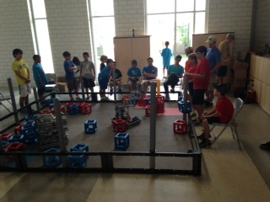Date:  November 19 – 21, 2018

Time:  9:00 – 3:00 (Before and After Care Available)

Ages:  7 – 13 years old, Boys and Girls (Only 45 spots available!)

Cost:  $150 ($175 with before and after care)

Before & After Care:  8am – 9am & 3pm – 4:30 pm

Location:  Holy Cross Cafeteria, 5500 Paris Avenue, NOLA 70122

Register Online:  <http://www.holycrosstigers.com/hc/parents/stem.aspx>

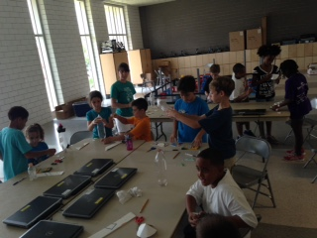

***Daily Schedule***

9:00 – 10:30: Science Experiments

10:30 – 12:00: Technology Projects

12:00 – 12:30: Lunch

12:30 – 2:00: Engineering Projects

2:00 – 3:00: Math Projects / Optional Tutoring